Bangia atropurpurea (Mertens ex Roth) C. Agardh 1824
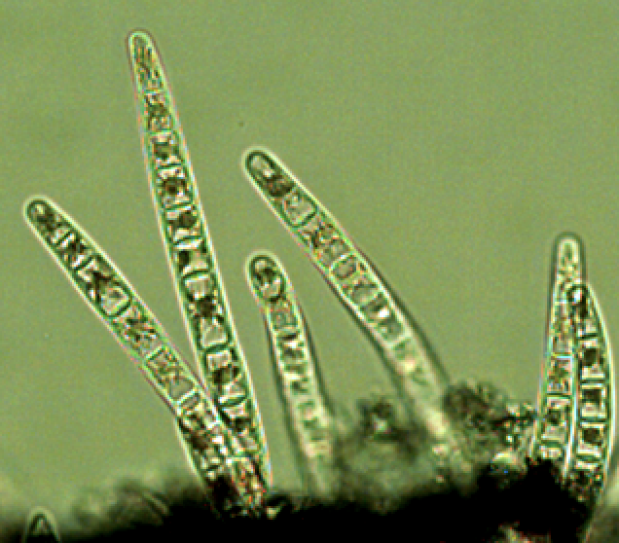

Phylum: Rhodophyta
Class: Bangiophyceae
Order: Bangiales

Habitat: benthos, periphyton
Distinctive attributes: filaments form dark fur-like fleecy mats at air-water interface in shallow waters (few cm) close to the waterline. The species is found in both marine and fresh waters.
Organization: filamentous (initially uniseriate, later multiseriate)
Color: dark red-brown
Cell diameter: ~ 20 μm (but highly variable)
Filament length: Several centimeters
Cell shape: cylinder

Morphological features: Bangia colonies made of filament aggregation are visible to the naked eye and distinct by their reddish-dark brown to black color (Plate 1). The colonies are attached to surfaces by down-growing rhizoids, usually in dense purple-black to rust-colored clumps. The individual filaments are gelatinous, unbranched. Young filaments are uniseriate (Plate 2), old filaments are multiseriate (Plate 3). A star-shaped chloroplast with prominent pyrenoid in the center of each cell is typical of the genus. So are cell elongations (Plate 4) occurring from intercalary cells, they are formed as a step in the reproductive cycle (Gargiulo et al. 2001).
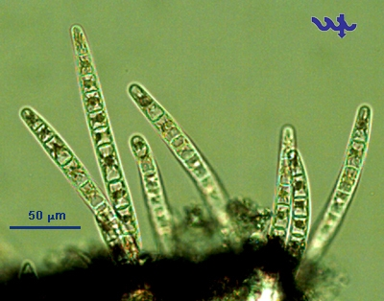
Plate 1. Mat-forming colony of Baniga atropurpurea with young filaments embedded in firm gelatinous matrix.

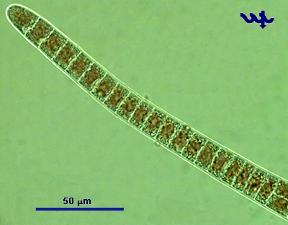
Plate 2. A young uniseriate filamenat of Baniga atropurpurea showing box shape of individual cells.
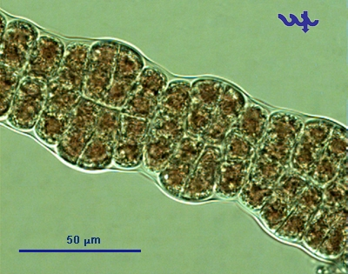
Plate 3. A mature, multiseriate filamenat of Baniga atropurpurea made of cells of different shapes and sizes.
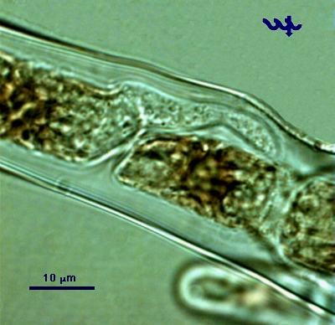
Plate 4. Close up on a uniseriate filament of Baniga atropurpurea showing development of colorless, rizoid-like structure from an intecalary cell.

Ecology: Seasonally occurring as a fleecy mat in the eulittoral zone of Lake Kinneret on near-shore hard surfaces (often concrete) in extremely shallow waters. It appears in December each year, for a few weeks, then disappears, to re-appear in following years. Since it is absent in the pelagial, where samples for our monitoring program are collected, we have no abundance nor size data for it.
Physiological features: Known as being a highly adaptive species due to its stress tolerance. Can survive desiccation and extreme solar radiation (in the supra-littoral zone).
Cite this record as:
Tamar Zohary, Alla Alster. 4 May 2026. Electronic publication. Israel Oceanographic & Limnological Research. [Date when last accessed].

